Contemporary Ancestral Goldsmithing, Gold
The fusion of photography and digital art becomes a contemporary form of symbolic goldsmithing, where light replaces gold and creates a new ritual body.
Ariadna Canaan
2026
Introduction
In the islands of the Caribbean and Central America, myths, legends, and unsolved mysteries converge, having played a leading role throughout history.
In Christopher Columbus’s journals, his writings and observations constituted the first verbal representation of the Caribbean islands and the New World. The Caribbean landscape enveloped him in an aura of magic, leading him to believe that he had discovered the earthly paradise.
However, in Columbus’s first journal, one of his primary objectives is evident: conquest and the search for the precious metal, gold.
At some point in history, Columbus lost interest in Hispaniola, now divided into the Dominican Republic and Haiti, as only fragments and gold nuggets were found in some rivers. It is said that he gradually lost interest in our island. However, history may hold a surprising twist: according to studies conducted in 2020–2021, the Dominican Republic ranks fourth in the world in gold exports.
In this Ancestral Goldsmithing collection, throughout the research and creative process, we discovered a series of pieces, including zemís, objects featuring Taíno characteristics that invite us to reconsider contemporary language and aesthetics.
In this series of digital artworks, created between 2019 and 2025, I used digital tools and photography. On this occasion, no AI was used; instead, the images were manipulated to create a collection of pieces representing gold ornaments, objects, and adornments, some intertwined with wild shrubs that resemble precious stones.
This collection represents the new gold: Technology, used as a technique to create these striking pieces.

Bibliography
Yolanda Wood
María A. Rueda
José Juan Arron
Conceptualization, creation, and presentation: Ariadna Canaan Studio

Ariadna Canaan Digital Art: Contemporary Ancestral Goldsmithing
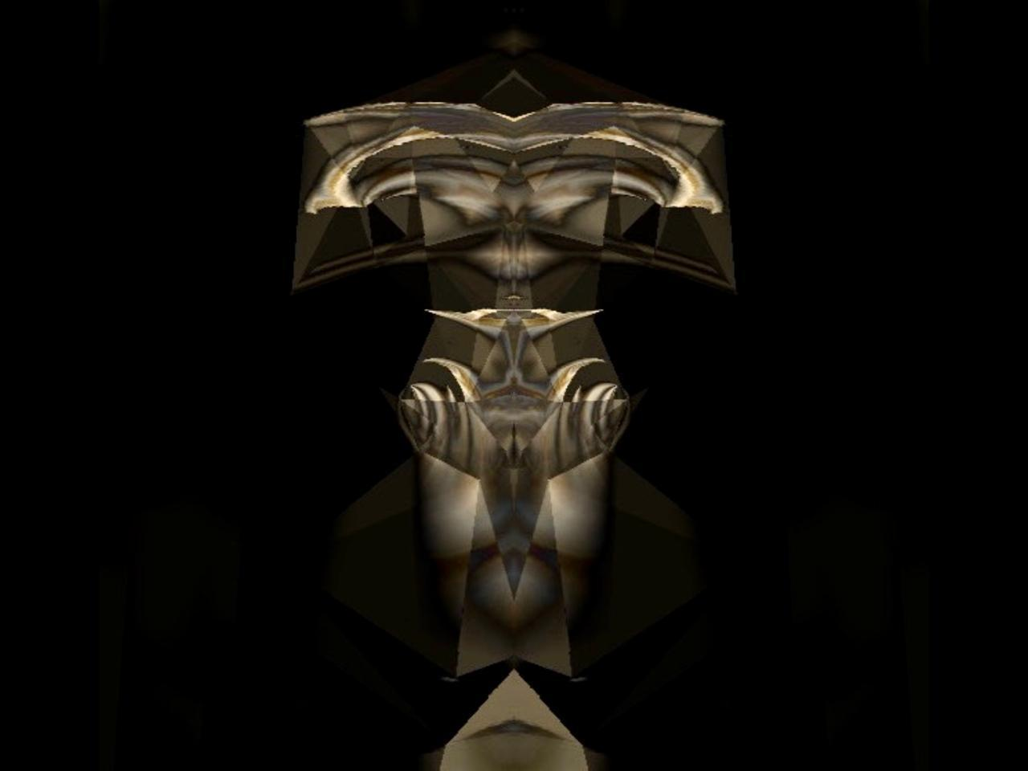

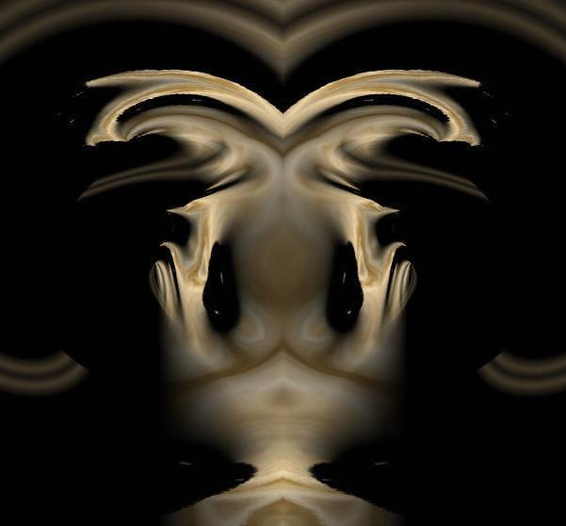

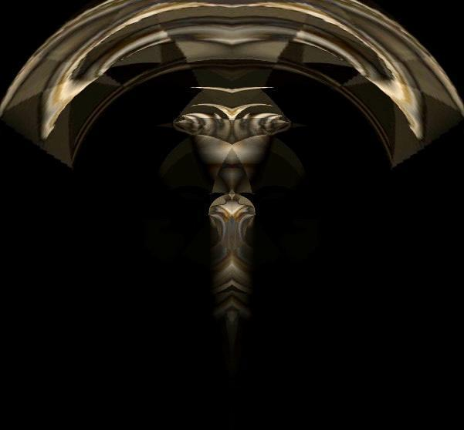

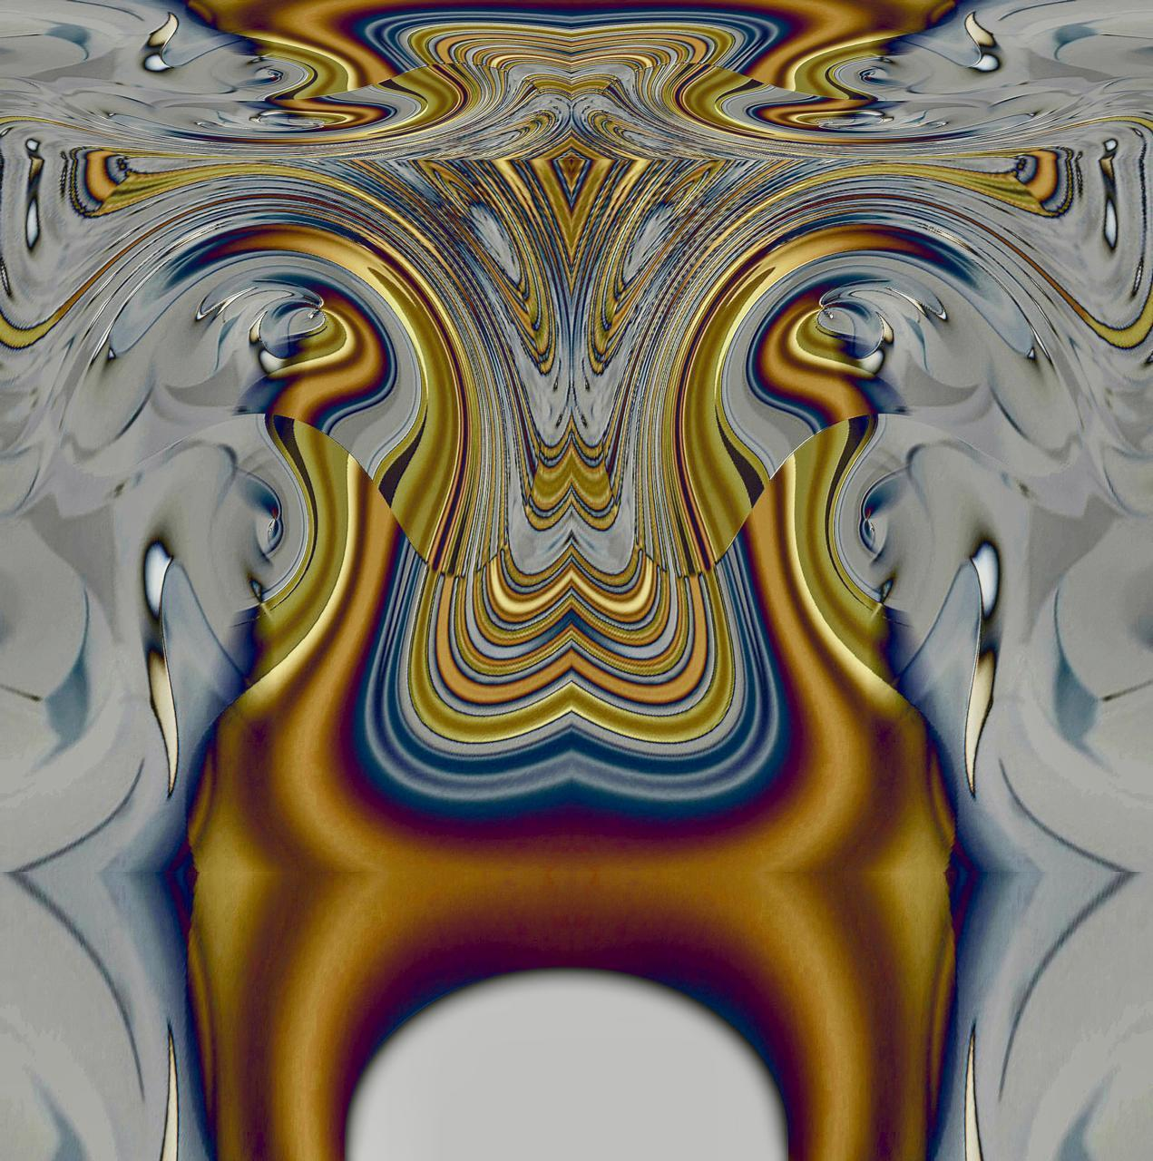

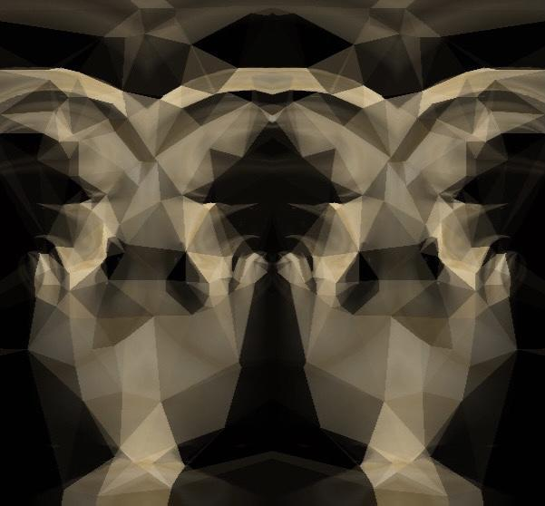

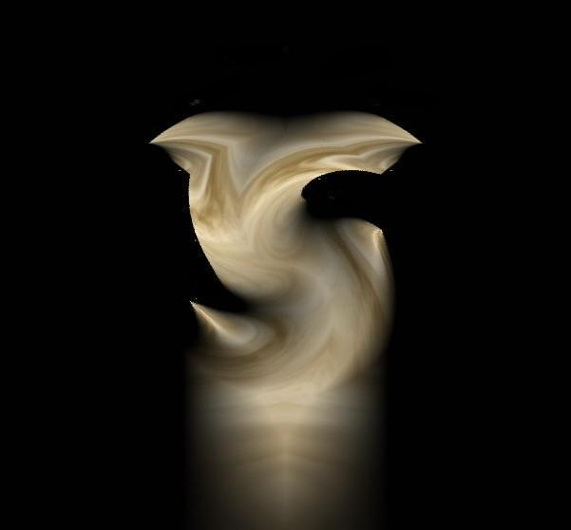

Author: Ariadna Canaan
Title: Contemporary Ancestral Goldsmithing, Gold.
Project: This project explores the relationships and connections between goldsmithing in gold and its various forms among the Indigenous peoples of the Caribbean and Central America during the 16th century. Using this as a point of reference, a project has been initiated to reinterpret these practices through a contemporary visual language.
Techniques: Digital art, collage, photography, video, audio, multimedia installation, and printing on various substrates.
Materials: Digital art, photography, LED screens, and other media.
Dimensions: Variable.
Years: 2019–2026.

Process and Creation
Road Map: In Search of Gold in the 16th Century
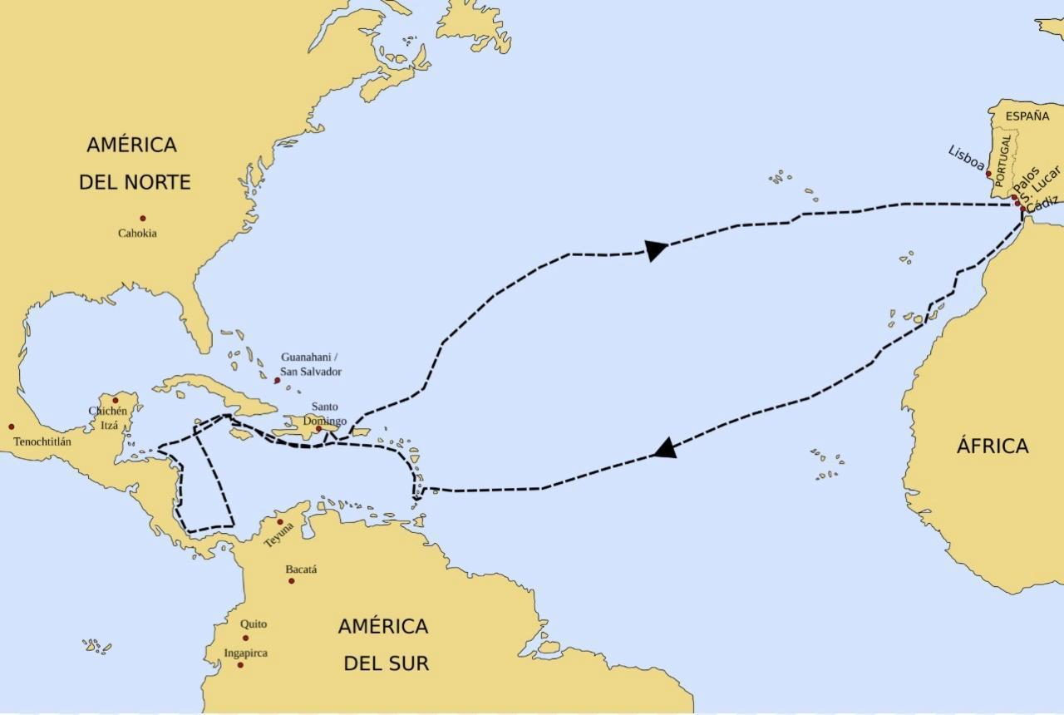

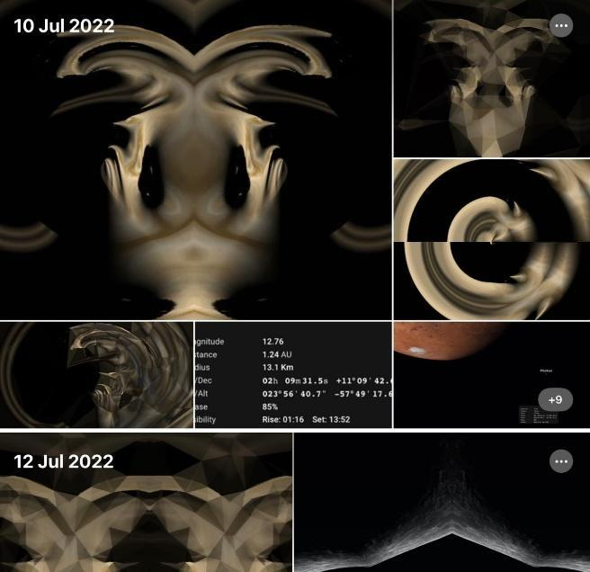

Beginning of the Digital Art Project and Research into the Gold Route: Characteristics, Similarities, and Ancestral and Contemporary Indigenous Practices
While working on my photographic project Soy Luna in 2021, a project centered on the alter ego that explores the Moon as a territory and a body in transformation, establishing a dialogue between the intimate and the celestial, I realized that I was creating and producing digital artworks that resembled shamans or amulets. I saved these images in my archives.
It was not until I met Dr. Yolanda Wood, a specialist in Caribbean art, that I shared my observations with her regarding certain peculiarities surrounding Columbus’s voyages and his search for gold. I explained that I was planning to develop a digital art project that I intended to call Ancestral Goldsmithing. To my surprise, she informed me that no contemporary artists were currently working on this subject and that we would continue to explore and develop the project.

Indigenous Goldsmithing, the Gold Route: Characteristics, Similarities, Connections, and Ancestral and Contemporary Practices
During his voyages between 1502 and 1504, Christopher Columbus traveled along the coasts of what are now Honduras, Nicaragua, Costa Rica, and Panama. In Panama, he heard accounts of regions rich in gold and observed that Indigenous peoples wore ornaments made from this metal, reinforcing his belief that great riches existed in the area. Panama and Costa Rica are particularly notable for their pre-Columbian Indigenous goldsmithing, featuring gold pieces of remarkable technical and symbolic sophistication. Both regions formed part of the cultural area associated with Greater Chiriquí, the Coclé culture, and the Diquís region, where an extraordinary tradition of goldworking developed between the 7th and 16th centuries.
Some of the characteristics of these pre-Columbian pieces include hammered and repoussé gold; representations of birds, jaguars, crocodiles, snakes, and hybrid beings; symmetry and geometric designs; ornamental, ceremonial, and funerary uses; and shamanism and spiritual transformation between human and animal forms.
In the case of the Taíno peoples of the Caribbean Antilles, they shared a similar vision of the spiritual world. The zemís were objects that embodied spiritual forces. However, their goldwork was more modest in comparison. Nevertheless, some of their metallurgical techniques were indeed connected to those practiced in Panama and Costa Rica.
The connection between Taíno cosmology and the goldsmithing traditions of Greater Chiriquí represents a rich and relatively unexplored conceptual direction in contemporary art.

Differences, Similarities, and Connections Between Pre-Columbian Indigenous Goldsmithing and Contemporary Digital Art

Pre-Columbian Indigenous Goldsmithing:
The use of the lost-wax casting technique allows for the creation of highly complex three-dimensional sculptures.
Gold, a precious material, was used for spiritual, ornamental, and shamanic purposes. Shamans assumed the supernatural qualities of animals.
Transformation of identity between human and animal forms and the cosmic forces.
Contemporary Digital Art:
The use of rendering technology to visualize 3D models or display them on LED screens.
The use of the color gold to represent power, light, and magic.
Significantly more complex pieces, with intricate details, layers, textures, and visual tonalities, offering infinite possibilities.
The Ancestral Goldsmithing project originated with the Moon and the cosmos.
The use of the alter ego, the transformation of identity, the fusion of different states of being, and the passage between visible and invisible worlds.
Aesthetic and sophisticated images intended for contemporary art exhibitions and the art collector market.

Examples of Pre-Columbian Artifacts from Greater Chiriquí, Coclé, and Diquís
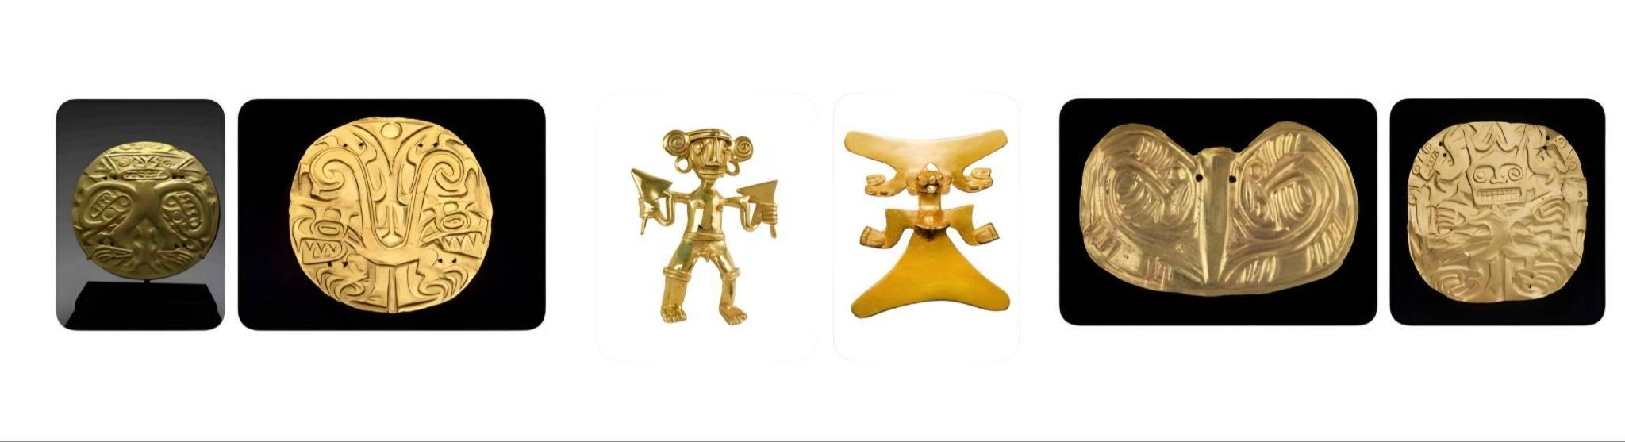

Example of a Contemporary Ancestral Goldsmithing Artwork: Gold
